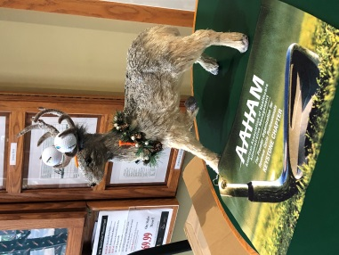
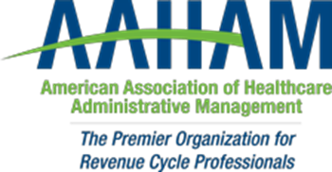
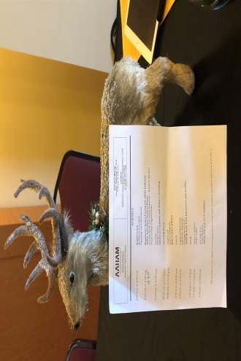

Pennsylvania Keystone Chapter

NAME the Mascot Contest!
As many of you have noticed throughout this year, The Keystone AAHAM Board has had a new “furry antlered” member appear at several functions.
The Board has decided to adopt him as our mascot.
Our newest member needs a name and our membership is going to help us decide via our name the mascot contest:
Contest Rules:
- Submit entries to tfedullo@nragroup.com
- Any Keystone AAHAM member is eligible to submit a name.
- One entry per member
- Entries may be submitted November 1st-30th 2019
- Winner will receive a $25 Starbucks Gift Card
- Board will select top five entries, vote will take place at December 12th 2019 Holiday meeting
- Winning name will be announced at December 12th 2019 Holiday meeting ($25 Starbucks GC)
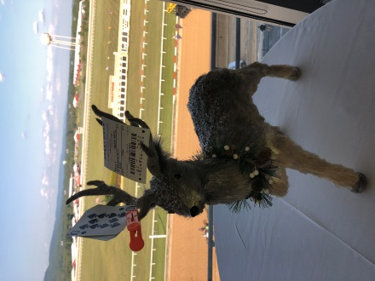
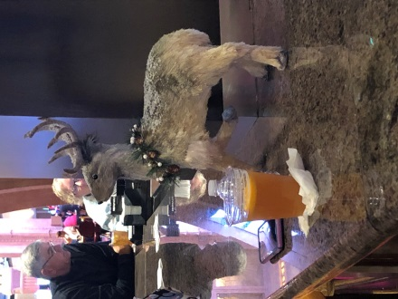
- Need not be present to win
What’s my Name?
I need your help?

