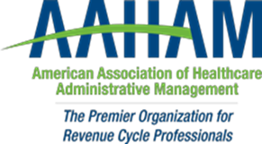

Pennsylvania Keystone Chapter

Keystone AAHAM’s 2nd annual
No Shave November - Contest
What’s your style?
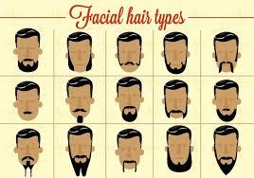

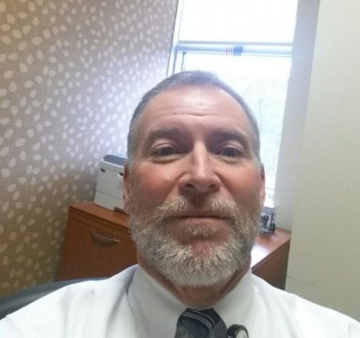

Reigning Champion
Keith Beck - CRCE

Keystone AAHAM’s Facial Hair contest will help support colorectal cancer awareness (www.fightcolorectalcancer.org)

Here are the rules:

- All participants must submit a picture of their entry by November 25th to Toney Fedullo tfedullo@nragroup.com
- Does not need to be a beard
- Pictures will be posted on the Keystone AAHAM website where anyone can vote for their favorite via on-site donation.
- Final voting will take place via cash donation jars at the keystone AAHAM winter holiday meeting December 12th
- Winner will receive a free meeting certificate.
- All proceeds will benefit the charity ‘Fight Colorectal Cancer’


