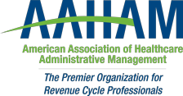

Pennsylvania Keystone Chapter

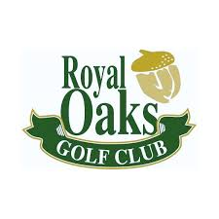
2019 Frank Gill Memorial Golf Outing


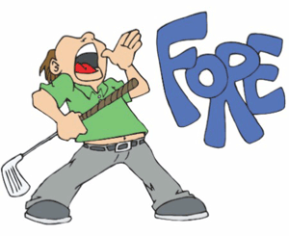

3350 West Oak Street
Lebanon, PA 17042

Friday August 23rd
10:00am Shotgun Start
(Four person scramble)
www.golfatroyaloaks.com

SPONSORSHIPS
$650 Contest hole SPONSOR - (includes foursome and tee sign on each contest hole)
Each golfer will receive golf, cart, Lunch, hot do, and (2) Drink tickets

$450 Foursome Sponsor - (includes Foursome and tee sign)
Each golfer will receive golf, cart, Lunch, hot dog, and (2) Drink tickets

Individual Golfer


$85 per golfer
Each golfer will receive golf, cart, Lunch, hot dog, and (2) Drink tickets

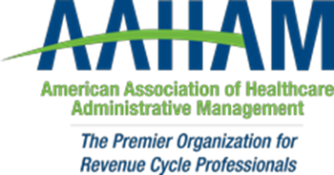

Pennsylvania Keystone Chapter

Golf Tournament Registration
Friday, August 23, 2019

Sponsorship includes a foursome for the event, signage on the golf course, hot dog, (2) drink tickets, and Lunch.

Name: _____________________________________________

Company: __________________________________________

Address: ______________________________________________________________

Phone: _____________________

Email:_________________________@_________________

Golfers in your group:

PRICING: Tee Sponsor $450 per group
Contest Hole Sponsor $650 per group
Single golfer $85

Name: _______________________________

Name: _______________________________

Name: _______________________________

Name: _______________________________

Please send payments (made out to KPAMA) and registrations made to:
Laurie Steffy- 1011 Hillcrest Road, Akron, PA 17501
Or
Pay by web – www.keystoneaaham.org and email registration to Laurie Steffy lsteffy2@wellspan.org

