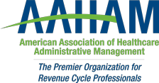

Pennsylvania Keystone Chapter

2021 Frank Gill Memorial Golf Outing
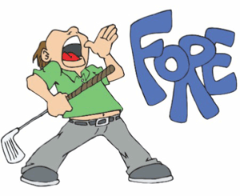

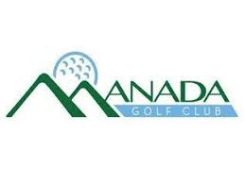
609 Golf Lane
Grantville, PA 17028

https://www.manadagolfclub.com/
Thursday, August 19th, 2021
11:00am Shotgun Start
(Four person scramble)
SPONSORSHIPS
$650 Contest hole SPONSOR - (includes foursome with cart and tee sign at each contest hole)
Each golfer will receive hot dog, 2 drink tickets, and lunch following tournament.

$450 Foursome Sponsor - (includes foursome with cart and one tee sign)
Each golfer will receive hot dog, 2 drink tickets, and lunch following tournament.

Individual Golfer


$85 per golfer
Each golfer will receive lunch, hot dog and 2 drink tickets.

Register online at https://keystoneaaham.org/meet-reg1.php?id=54 or
complete the form below. If you have any questions, please contact
Toney Fedullo at tfedullo@nragroup.com

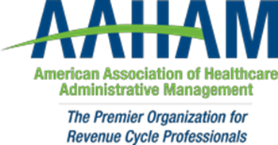

Pennsylvania Keystone Chapter

Golf Tournament Registration Deadline
Friday, August 13, 2021

Sponsorship includes a foursome with golf cart for the event, signage on the golf course, as well as a hot dog, 2 drink tickets, and lunch following tournament for each golfer.

Name: _____________________________________________

Company: __________________________________________

Address: ______________________________________________________________

Phone: _____________________

Email:_________________________@_________________

Golfers in your group:

PRICING: Tee Sponsor $450 per group
Contest Hole Sponsor $650 per group
Single Golfer $85

Name: _______________________________

Name: _______________________________

Name: _______________________________

Name: _______________________________

Please send checks (payable to KPAMA) along with completed registration form to:
Laurie Steffy- 1011 Hillcrest Road, Akron, PA 17501
OR
Register online – https://keystoneaaham.org/meet-reg1.php?id=54

