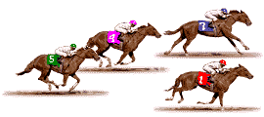
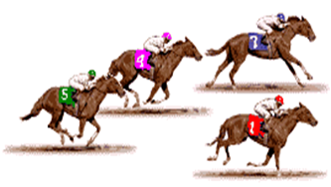
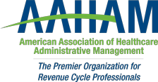

Pennsylvania Keystone Chapter
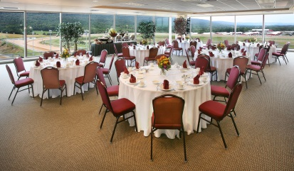
Thursday, July 25th, 2019
is
POST TIME!

Keystone AAHAM is hosting dinner and a “Night at the Track” following the July 25th educational meeting.

Join us at Penn National Race Track and enjoy a day of education and an evening of racing from high above Penn National in an exclusive climate-controlled suite.
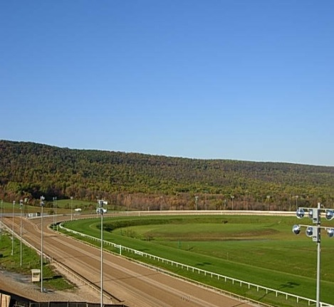
Our educational meeting will start in the afternoon and finish with an evening of dinner, thoroughbred racing, and networking!
1:00 - 1:30 PM – Registration
1:30 - 5:00 PM – Educational meeting
- Featuring National AAHAM Education Chair - Kate Clark’s “Common Denominator Communication”
5:00 - 6:00 PM - Drinks and dinner
6:00PM – First Race

**There may even be some contests to win betting vouchers**


Enjoy a day of education and a night away with friends and colleagues.

Hollywood Casino
777 Hollywood Blvd.
Grantville, PA 17028

