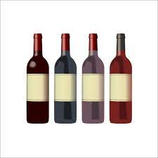
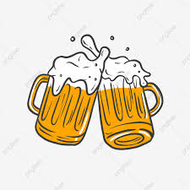
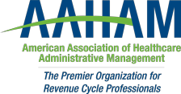

Pennsylvania Keystone Chapter

Networking Event
HAPPY HOUR AND WINE TASTING
(beer and heavy APPETIZERS too!)
Please join us for an evening of catching up, reconnecting, and wine tasting with colleagues/friends new and old.

Thursday, July 22nd 2021
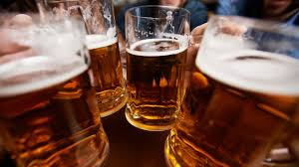
5:00 - 8:00pm

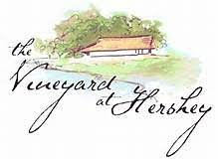

The Vineyard at Hershey, 598 Schoolhouse Rd, Middletown, PA 17057

The Vineyard & Brewery at Hershey handcrafts every bottle for the enjoyment of new and the most experienced of palates. We trust you will taste the difference, and may our creations inspire your happy hour conversations. Our philosophy is that enjoying an artfully crafted wine or beer is meant to be a shared experience with family and friends.

Please RSVP via link https://keystoneaaham.org/meet-reg1.php?id=52


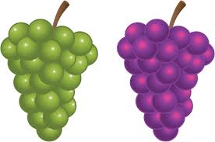

We have secured hotel rooms at Fairfield Inn & Suites Harrisburg/Hershey for $114-$125/night, Reserve by 6/21 Book your group rate for Health Care Event at Hershey Vineyard

