AGENDA

8:00 a.m. to 8:45 a.m. Registration
Breakfast Provided

8:45 a.m. to 9:00 a.m. Welcoming Remarks

9:00 a.m. to 10:00 a.m. How to Play Ball with Prior Authorizations
Peter Angerhofer, Principal, Colburn Hill Group
As the payor prior authorization game becomes harder to play, healthcare providers and physicians struggle to keep track of the rules and guidelines. In the meantime, “new” prior authorization come into play as payors change the game by adding levels of complexity and various turnaround time requirements that are difficult to navigate.

10:00 a.m. to 10:50 a.m. Lean into Healthcare Revenue Cycle
Sara Woodbury MSW, MPM, LSSBB & Jennifer Nichols, MAC
Penn State Health
Objectives:
- Verbalize and understand of basic principle of Lean
- Demonstrate an understanding of foundation of Lean tools
- Discuss application of Lean principles and tools in Healthcare

10:50 a.m. to 11:10 a.m. Morning Break

11:10 a.m. to 12:00 .m. Lean into Healthcare Revenue Cycle (part 2)

12:00 p.m. to 1:00 p.m. Lunch

1:00 p.m. to 1:45 p.m. HAP Update
Speaker: Jolene Calla

1:45 p.m. to 2:30 p.m. Open Forum
New to “Keystone”
Bring your ideas and hot topics to be discussed at our next meeting!

2:30 p.m. to 3:15 p.m. Update Speakers
Roxanne Beaver, Capital Blue Cross
Diane Minetola, Highmark
Diane Hess, Novitas

Please join us for these exciting presentations and certified members will earn9.5 CEU’s
Directions

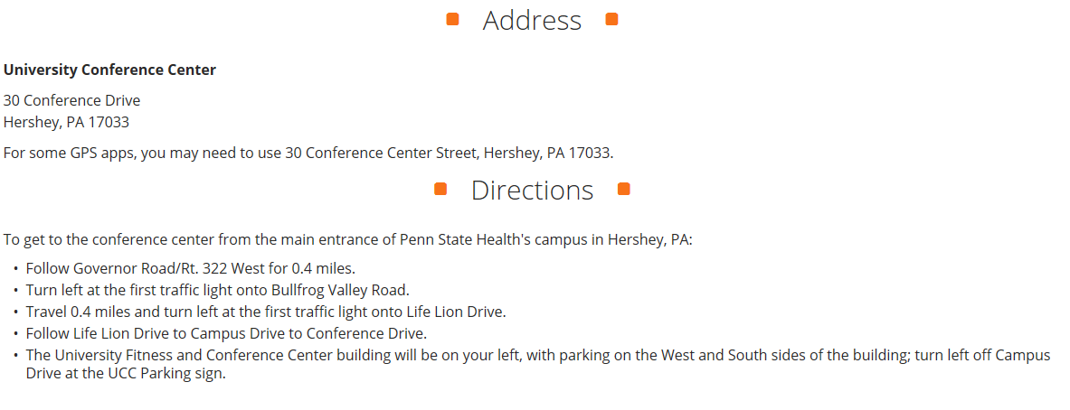

About our Speakers

Peter Angerhofer is a principal at Colburn Hill Group; he brings experience in operations, strategy and health policy to both the daily operations as well as long-term vision. Prior to forming Colburn Hill, Peter had been part of the original, pre-revenue start-up team of eight at Accretive Health. There he helped to develop the company’s operating model, and spent 10 years managing operations. For example, Peter managed the daily Patient Access and Patient Financial Services activities at several Accretive clients, such as a $1.2b academic medical center and a $400m community hospital. He improved total collections by more than 4% and reduced client costs by more than 20%. Peter’s depth of experience and breadth of vision allows him to move easily from working with line staff on performance improvement to C-suite discussions of strategic imperatives. Prior to Accretive, Peter worked for Deloitte Consulting and CSC/APM, as well as serving in health policy roles on Capitol Hill.

Jolene H Calla, Esquire
Vice President of Health Care Finance and Insurance
The Hospital and Healthsystem Association of Pennsylvania, (HAP)

Ms. Calla currently serves as the Vice President of Health Care Finance and Insurance for the Hospital and Healthsystem Association of Pennsylvania (HAP). In this role, Ms. Calla directs all activities related to health care finance, including Medicare, Medicaid, and other government reimbursement for health care providers. Her responsibilities include detailed understanding and analysis of state and federal budgets, as well as a comprehensive knowledge of legislation and regulation impacting hospital and health system finances, reimbursement, tax exemption of not-for-profit hospitals, and hospital charity care and billing practices across the continuum of care.

Ms. Calla frequently participates in negotiations with government agencies and representatives of outside organizations on behalf of HAP. Prior to joining HAP, Ms. Calla served the Commonwealth of Pennsylvania for several years as Bureau Director for the Office of Medical Assistance Programs where she directed all operations and implemented multiple federal and state initiatives. Ms. Calla was the only person to lead both the Fee-for-Service and the Managed Care delivery systems. Ms. Calla’s prior positions afford her extensive expertise in the health care and insurance industry, with a concentration in managed care. She worked as a Special Projects Consultant for Capital BlueCross, as the Director of Group Administration, Strategy and Process for Coventry Health Care and as Director of Marketing and Corporate Communications for Keystone Health Plan Central. Ms. Calla received her Juris Doctorate from the Widener University School of Law, her Master of Arts in Communication Arts from the New York Institute of Technology, and her Bachelor of Arts in English and Bachelor of Arts in Communication Arts from Villanova University.

Sara Woodbury MSW, MPM, LSSBB
Operational Excellence Senior Consultant

Ms. Woodbury is a healthcare professional with a unique set of clinical, technical, and leadership skills who specializes in change management, resource development, and cross-functional collaboration. Since joining Penn State Hershey she has led successful initiatives in service recovery, capacity management, handoff communication, ED throughput, ambulatory clinical quality improvement, and ambulatory diagnosis capture. Her experience in clinical, technical, and quality realms augmented by her social work, project management, lean six sigma training are assets to her clients as she partners with them to achieve meaningful and sustainable results.

Jennifer Nichols, MAC
Operational Excellence Associate
Ms. Nichols is a lean six sigma trained healthcare professional with a focus on clinical effectiveness, data analysis and facilitation projects designed to add value to clinical, technical and support departments of the medical center. She has led successful initiatives in call center management, process efficiency and turnaround time in both clinical and non-clinical settings. Her experience with finance, reporting and data analysis provide a unique resource for the development of management reporting tools for operational leaders. Prior to joining Penn State Hershey she spent over ten years in financial and litigation consulting roles.

REGISTRATION FORM

Please register the following individuals for the March 26, 2019 Keystone AAHAM Chapter Meeting.
______________________________________________________
Name of Organization

______________________________ ______________________ ____________________ ___________________ __________________
Name of Attendee (1) Title/Position Chapter Affiliation AAHAM/HFMA/ Non-Member
Keystone/NE/Phila NAHAM
______________________________
Email Address (1)

______________________________ ______________________ ____________________ ___________________ __________________
Name of Attendee (1) Title/Position Chapter Affiliation AAHAM/HFMA/ Non-Member
Keystone/NE/Phila NAHAM
______________________________
Email Address (1)

______________________________ ______________________ ____________________ ___________________ __________________
Name of Attendee (1) Title/Position Chapter Affiliation AAHAM/HFMA/ Non-Member
Keystone/NE/Phila NAHAM
______________________________
Email Address (1)

MEETING FEES:
AAHAM Member $75.00 Check should be made payable to KPAMA
HFMA/NAHAM Member $75.00 Check for $_____________ enclosed
Non-member $100.00
Full-time Student Member Free

IT’S EASY TO REGISTER ON-LINE, JUST VISIT THE KEYSTONE CHAPTER
WEB SITE:
WWW.KEYSTONEAAHAM.ORG
Or, send your registration form and check to:
Laurie Steffy
1011 Hillcrest Road
Akron, PA 17501
Lsteffy2@wellspan.org

