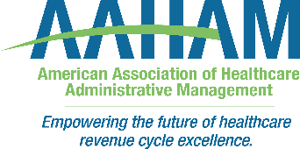

PA/NJ AAHAM Annual Institute

Keystone, Philadelphia, New Jersey, and Three Rivers Chapters of AAHAM

DATE: Thursday, May 14, 2026

LOCATION: Wind Creek Casino Resort Bethlehem

77 Sands Boulevard, Bethlehem, PA 18015

COST: $125 AAHAM Member $150 Non-Member

**5.25 Educational Hours = 10.5 AAHAM CEUs**

The Keystone, Philadelphia, New Jersey, and Three Rivers Chapters of AAHAM are pleased to present this year’s Annual Institute and Sponsor Fair. Come join us for a day of education and networking with peers and vendor partners.

AGENDA
07:30 AM —08:30 AM | Registration, Breakfast, & Sponsor Exhibits | Meeting Room - Moravian Room  Exhibitor Hall - Monocacy Room
08:30 AM —08:45 AM | Welcome/Announcements | Chapter Presidents
08:45 AM —9:45 AM | Journey to Financial Clearance Centralization  Topic Summary: The presentation will be an overview of operational and workflow changes to create a One Radiology Model. | Nakita Robinson  Associate Director Financial Clearance  Penn Medicine
9:45 AM —10:15 AM | Networking Break | Exhibitor Hall - Monocacy Room
10:15 AM -- 11:15 AM | Optimizing Visit Revenue with CLARE | Jazmyn Cunningham  Manager, Physician Billing Revenue Cycle Education & Support  St. Luke’s University Health Network
11:15 AM – 12:15 PM | Compliance or Consequences: Navigating Revenue Cycle Risk in 2026 | Karen M. Smith, MBA, CPA, CHC, CHPC  VP & Billing Compliance Officer  Penn Medicine  Al’Asia Powell, RN, MPA, CPHQ, CSSBB  Director of Corporate Compliance  Inspira Health  Cheryl Straup  Chief Compliance & Privacy Officer, Main Line Health  Erin Witkosky  Director, Corporate Compliance & Privacy, ChristianaCare
12:15 AM —1:15 PM | Lunch | Meeting Room - Moravian Room
1:15 PM --- 2:15 PM | Leadership Presentation | Reggie Hodges  VP of Sales, Capio
2:15 PM – 2:30 PM | Networking Break | Exhibitor Hall - Monocacy Room
2:30 PM – 3:45 PM | Revenue Cycle: Simplify to Strengthen: Eliminating Waste in Revenue Cycle  Healthcare organizations continue to experience sustained margin pressure while navigating centralization efforts, workforce shifts, automation initiatives, vendor partnerships, and broader operational transformation.  This panel will shift the focus from traditional revenue cycle topics (denials categories, AR days, payer updates) to a strategic discussion on identifying operational waste and translating efficiency improvements into measurable financial impact. | Jason Kane  Vice President of Revenue Cycle for Inspira Health  Annabelle Seippel-Hunt  Associate Vice President, Denials Management & Revenue Integrity  Capital Health  Dan Bean  Applied AI Lead for R1  Sherry Onushco  Associate Vice President, Registration – Jefferson Health
3:45 PM – 4:15PM | Closing Remarks/Exhibitor Raffles/Drawings | Meeting Room - Moravian Room

Reggie Hodges
Vice President of Sales
Capio
Before his healthcare career, Reggie spent eight years as a professional athlete in the NFL, an experience that shaped his disciplined, high-performance leadership style. He is also a frequent industry speaker and motivator, drawing on his experience in professional sports and healthcare to inspire teams and help organizations perform under pressure.

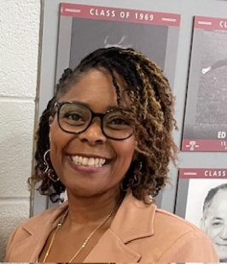
Nakita Robinson
Associate Director of Financial Clearance at Penn Medicine
Nakita has extensive experience in patient financial services and healthcare operations. She began her career at Penn Medicine in 1997 as a Senior Secretary in the Cardiology Department. Since then, she has held various positions within Revenue cycle notably as a Financial Counselor in Patient Financial Services and then promoted as a Supervisor. In 2016, Nakita was selected to participate in Phase 2 of the PennChart project as a Credential Educator. During this year’s long initiative, she played a key role in system implementation and staff training. Following the successful completion of the program in 2017, she returned to her position as Supervisor of the Patient Financial Advocacy group. For the past 6 years Nakita has transitioned to the Radiology Department as the Manager of Radiology Patient Access and Financial Clearance and now as an Associate Director, where she continues to contribute to the Centralization of Financial Clearance. Her career reflects a strong commitment to operational excellence, staff development, and improving the patient financial experience.

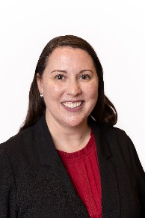
Karen M. Smith, MBA, CPA, CHC, CHPC
Vice President, Billing Compliance at Penn Medicine
Karen is the Vice President and Billing Compliance Officer at Penn Medicine. Karen has over 20 years’ experience in health system compliance & privacy, revenue cycle and internal audit.

Karen is responsible for administering the billing compliance program for Penn Medicine, as well as planning, coordinating, and managing compliance reviews and education programs. Karen oversees due diligence audits, government audits, and appeals to include third-party reserves related to compliance matters.

Karen earned a bachelor's degree in economics from The Wharton School at the University of Pennsylvania and a master's degree in business administration from The Fox School of Business at Temple University. She is also a certified public accountant with additional healthcare and privacy compliance certifications.


Al’Asia Powell
Director of Corporate Compliance for Inspira Health

Al’Asia previously served as the Director of Quality and Patient Safety for Inspira LIFE. In her current role, Al’Asia supports the operationalization of Inspira’s network-wide Corporate Compliance Program, ensuring alignment with applicable federal and state laws and regulations. She assists with the development, implementation and ongoing management of compliance policies, procedures and programs across the health system.
Al’Asia plays a key role in supporting regulatory compliance efforts for both internal and external stakeholders, including assisting with the resolution of compliance-related concerns involving staff, patients and family members in coordination with external regulatory agencies. She also partners with corporate compliance leadership to communicate compliance expectations through written materials and training programs designed to promote awareness, accountability and understanding of compliance standards and the consequences of non-compliance.
In addition to her current role, Al’Asia previously served as the executive sponsor for a major service area expansion at Inspira LIFE, which increased access to services for participants living in Salem and Gloucester counties and contributed to the overall growth and success of the program.
Al’Asia earned her Bachelor of Science degree in Public Health from Rutgers University in New Brunswick, NJ and a Master of Public Administration from Fairleigh Dickinson University in Teaneck, NJ. She has also completed an Advanced Graduate Certificate Program at St. Joseph’s University in Philadelphia, PA and an Associate Degree in Nursing from Rowan College of South Jersey in Deptford Township, NJ. Her accomplishments include serving as a keynote speaker at the National PACE Conference and the Truchart National User Group Conference. Al’Asia is a Fellow of the Advisory Board, a Certified Professional in Healthcare Quality and a Certified Six Sigma Black Belt. She received the Quality Improvement Award in 2020 and the New Jersey Hospital Association Innovation in Elder Services Award in 2022.

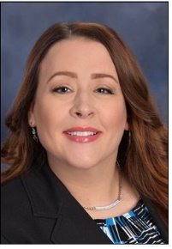
Erin Witkosky, BSN, CHC, CHPC
Interim Chief Compliance & Privacy Officer for ChristianaCare,
In her current role, Ms. Witkosky partners across the enterprise to identify, investigate, and mitigate compliance and privacy regulatory risks, including developing and executing the annual compliance workplan. She advises executive leadership and the Board on compliance and privacy risk and regulatory developments; leads enterprise privacy governance; and supports a culture of ethics, accountability, and continuous improvement. She also serves as the Compliance Officer for ChristianaCare Clinical Alliance and the eBrightHealth ACO.
With over 25 years of healthcare, compliance, and audit experience, she is a strategic leader with a detailed understanding of the clinical, financial, and operational complexities of large healthcare systems. Prior to working in compliance, she served in various nursing roles, primarily in trauma/surgical intensive care and ambulatory services. Ms. Witkosky holds bachelor’s degrees in both nursing and business administration and is certified in Healthcare Compliance (CHC) and Healthcare Privacy Compliance (CHPC).

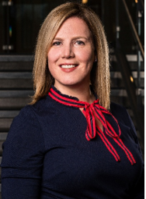
Cheryl Straup, MJ, CHC
Chief Compliance & Privacy Officer, Main Line Health

Cheryl Straup serves as the Chief Compliance and Privacy Officer at Main Line Health, a four-hospital not-for-profit health system serving communities across southeastern Pennsylvania. In this role, Cheryl leads the development and execution of the organization’s enterprise-wide compliance, privacy, and regulatory strategy. She is responsible for maintaining the integrity of Main Line Health’s operations through proactive risk identification, regulatory oversight, and the implementation of effective compliance controls aligned with OIG and DOJ program expectations.
Cheryl brings more than 18 years of experience in health care compliance, with a specific focus on billing integrity, fraud prevention, and operational transparency. Her expertise spans hospital and physician billing compliance, HIPAA privacy and security, Stark Law and Anti-Kickback Statute, EMTALA, and Medicare reimbursement and cost reporting. She has successfully led organizational transformations including department restructuring, governance redesign, and the development of a targeted billing compliance strategy in collaboration with internal stakeholders and external advisors.
As a member of the senior leadership team, Cheryl partners closely with executives across legal, operations, finance, and clinical departments to ensure Main Line Health’s strategic priorities are pursued in a compliant, patient-centered, and sustainable manner. She is also a participant in the Advisory Board Fellowship, where her practicum project centers on advancing enterprise risk management and adaptive leadership capabilities.
Cheryl holds a Master of Jurisprudence in Health Law and Compliance from Widener University Delaware Law School and is certified in healthcare compliance (CHC) through the Health Care Compliance Association.

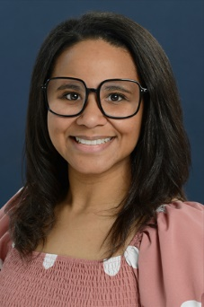
Jazmyn Cunningham
Manager of Physician Billing Revenue Cycle Education & Support
St. Luke’s University Health Network.

In this role, I provide strategic leadership over Registration Denials, network websites, and Physician Billing Operational Education, supporting organizational excellence and front-end revenue integrity. With more than 12 years of healthcare experience, I have built a strong reputation as a knowledgeable and collaborative leader within the revenue cycle space.
Throughout my career, I have contributed to meaningful advancements across the network, including significant improvements to outpatient charge reconciliation, charge review and claims enhancements, and registration and eligibility verification processes. I have also played a key role in developing updated education workflows and expanding course offerings designed to strengthen end-user knowledge, improve operational performance, and ensure a positive and efficient patient check-in experience.
I am a proud graduate of Northampton Community College and remain deeply connected to my local roots. Outside of work, I enjoy spending quality time with my three children and taking long drives while listening to a great song.
Healthcare is a constantly evolving field, and I am honored to serve as a trusted resource, partner, and advocate for teamwork and continuous learning in every professional interaction.

Annabelle Seippel-Hunt
Associate Vice President, Denials Management & Revenue Integrity
Capital Health
Annabelle is the Associate Vice President of Denials Management and Revenue Integrity at Capital Health System, collaborating across the organization to achieve sustainable financial and operational results. With 16 years of experience in revenue cycle management, she has consulted for hospitals nationwide, focusing on analyzing and preventing denial root causes.

Her leadership has enabled a team of over 200 professionals to recover more than $500 million in revenue for clients. Prior to her role at Capital Health, Annabelle advanced through senior positions at CorroHealth (formerly Aergo), MedMetrix, and nThrive, honing her skills in revenue optimization and operational efficiency. She is an active member of the Healthcare Financial Management Association (HFMA) and holds their Certified Revenue Cycle Representative (CRCR) certification. Annabelle also received dual bachelor’s degrees from William Paterson University.


Jason Kane
Vice President of Revenue Cycle for Inspira Health
Jason oversees enterprise-wide functions including Patient Access, Health Information Management, coding operations, Clinical Documentation Integrity, revenue integrity, managed care contracting, and business office operations.

He has extensive leadership experience across large health systems, leading Epic EMR implementations, major revenue cycle transformation initiatives, and achieving measurable improvements in collections, accounts receivable performance, and operational efficiency. Jason also serves as Vice President of the Philadelphia Chapter of AAHAM and is an active member of HFMA.

Dan Bean
Applied AI Lead for R1

Dan joined Phare Health as its first AI hire to build the production AI system, powering its coding & CDI tools. Since the acquisition of Phare by R1 RCM, he now leads applied AI for R37, R1's technology organization. In this role he focuses on use cases across revenue cycle but spends most of his time on models focused autonomous coding, concurrent CDI & DRG validation.

Prior to Phare & R1, Dan worked at AstraZeneca, leading data science and AI initiatives to support clinical trial success. He holds a PhD from Cambridge in Biochemistry. He resides in Brooklyn, NY with his wife & son, but is originally from the UK.

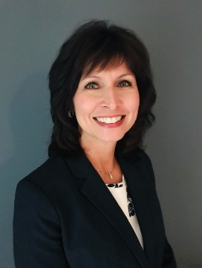
Sherry Onushco
Associate Vice President, Registration – Jefferson Health
Sherry is a seasoned healthcare leader with more than 20 years of experience advancing operational excellence across network-wide revenue cycle functions. She has led large scale initiatives that reduced avoidable write-offs, improved registration quality assurance, streamlined registration workflows, optimized EMR workflows supporting technology implementations and eliminated waste through standard work, centralization, and data-drive process improvement.

In her current role, she oversees registration across Jefferson Health. Sherry earned an MBA in Healthcare Systems Management from DeSales University and is a Certified Revenue Cycle Representative.

